**Disclaimer: The content is curated from online/offline resources and used for educational purpose only**

**Code Repository**

**LAB MANUAL**

**Pushing and Pulling Updates from Remote Repositories**

**Objective:**

* Push local commits to a remote repository.
* Pull changes from a remote repository to keep the local repository updated.
* Resolve simple merge conflicts that may occur during pulling.
* Understand best practices for syncing code in collaborative environments.

**Equipment Required:**

* Computer with internet access
* Git installed on the system
* GitHub or GitLab account (or any remote repository provider)
* Git Bash (Windows) or Terminal (macOS/Linux)
* Code/text editor (e.g., VS Code, Notepad++)

**Prerequisites:**

* Basic knowledge of Git and GitHub
* Ability to commit changes locally
* Working GitHub repository connected to your local repository

**Problem Statement:**

You are collaborating with a team using GitHub. You need to sync your local repository with the latest remote updates and push your own changes to ensure everyone on the team has access to your contributions.

**Procedure:**

**Step 1: Pull Latest Changes from Remote**



**Step 2: Pull Updates from the Remote Repository**

**Run the following command:**

**If your local branch is main (not master), then this will not work as expected. You should use:**



**Step 3: Make a Local Change**

1. Open the repo folder in your editor.
2. Edit or create a file named sync_demo.txt.
3. Add the following line: “This update demonstrates pulling and pushing changes in Git.”

**Step 4: Stage and Commit Your Changes**



**Step 5: Push Changes to the Remote Repository**

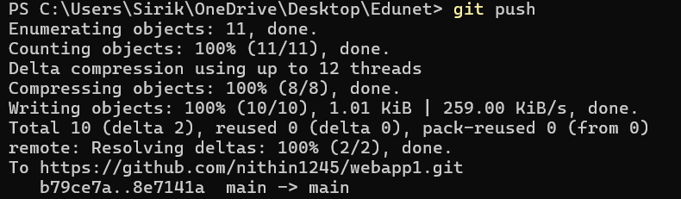

**Step 6: Confirm on GitHub**

Visit your GitHub repository in a browser and confirm that sync_demo.txt has been added and committed successfully.

